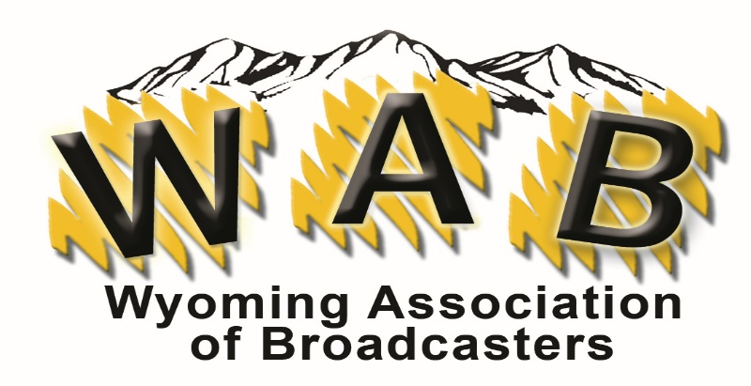

HALL OF FAME NOMINATION FORM
Deadline: November 30th
To nominate a Wyoming broadcaster, please answer the questions below the best you can. If any nominee is not selected for the current year, their nomination may be considered in future years. The nominee must have worked in Wyoming broadcasting for at least 15 years. Inductees are selected based on their contributions to broadcasting (statewide and nationally), their communities, and the state of Wyoming. Nominees may be active, retired, or deceased.

Name of Wyoming Broadcaster being Nominated: Name:______________________________________________________ Station:_______________
Name of nominator:________________________________________________________________
Station Call Letters:_____________________________ Phone:______________________________
E-Mail:___________________________________________________________________________

- How many years has the nominee been a Wyoming broadcaster?____________________
How many years has the nominee been a broadcaster?_____________________________

- Which station(s) has this broadcaster worked?
Call Letters:_________ Position held: __________________ City:____________________
Call Letters:_________ Position held: __________________ City:____________________
Call Letters:_________ Position held: __________________ City:____________________
Call Letters:_________ Position held: __________________ City:____________________
- Please submit a word document stating the reason for the nomination including key contributions to broadcasting, personal and professional involvement in community. Include highlights of their leadership, attributes, and characteristics that distinguish(ed) them among their peers. Any additional supporting documentation would be helpful, up to three pages.

- Posthumous only: Name of nearest living relative:_____________________
Phone:___________________________
Submit nomination form to: lauragrott@gmail.com or WAB/Box 1387/Cheyenne, WY 82003

CRITERIA FOR WYOMING ASSOCIATION OF BROADCASTERS HALL OF FAME

CANDIDATES
- Candidates must have worked in a broadcast related field for at least 15 years in Wyoming.
- Nominations are open to any broadcast related field (engineering, traffic, sales, on-air, GM, sports, etc.)
- Nominees that have been part of the WAB or work at a WAB member station will get preferred consideration.
- Candidates may be nominated by fellow broadcasters or any interested party (family members, etc.).
- Size of market or type of station will have no bearing on the final selection.
SELECTION PROCESS
All nominations will be reviewed and selected by the WAB Board of Directors. If for any reason someone on the Board is nominated, they won’t be part of the judging process that year.
JUDGING
Judging will be based on, but not necessarily limited to, the following:
- Key Contributions to broadcasting, personal & professional involvement in community
- Leadership, attributes and characteristics and distinguish them among their peers

